General Practice Pharmacist Foundation Programme:
Portfolio user guide

Contents
How to find and log in to the portfolio system | 3
How to navigate between the Domains and Competencies | 5
How to add a rating to a competency | 6
How to upload a piece of evidence into the portfolio | 7
How to attach an uploaded piece of evidence to a competency | 10
How to communicate with your Educational supervisor | 12
How to complete your Domains for review | 13
How to submit your completed portfolio to NICPLD for assessment | 16

How to find and log in to the portfolio system
1. To access the portfolio system, go to the NICPLD website (www.nicpld.org) and log in as you would normally.

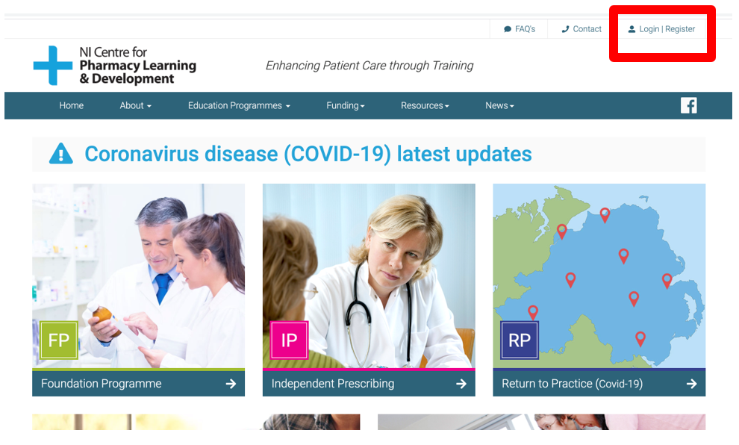

2. Once logged in, use the main menu to navigate to ‘Education Programmes’ and select ‘Foundation programme’.

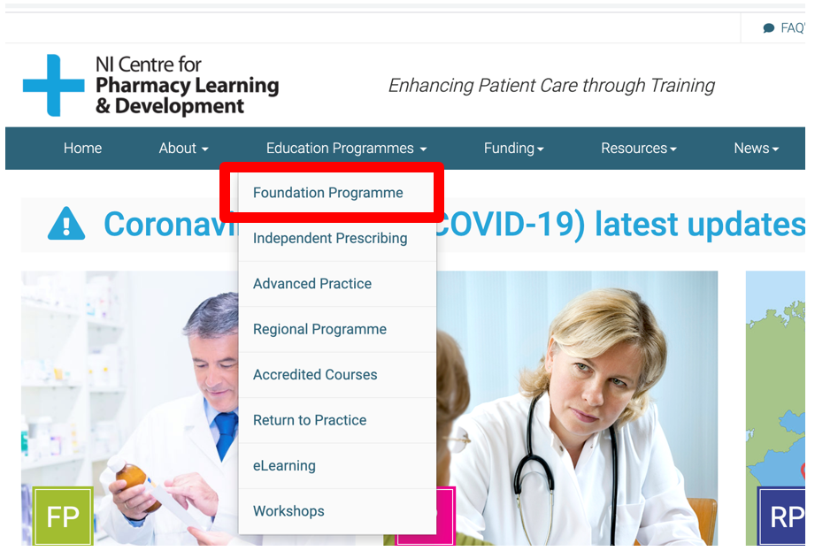

3. When the ‘Foundation Programme’ page is selected, a sub-menu will appear on the right-hand side of the screen. The ePortfolio is the last link on this sub-menu as shown below. Select ‘ePortfolio’ to open the portfolio in a new window. You will be automatically logged into the portfolio system as you have already logged into NICPLD.

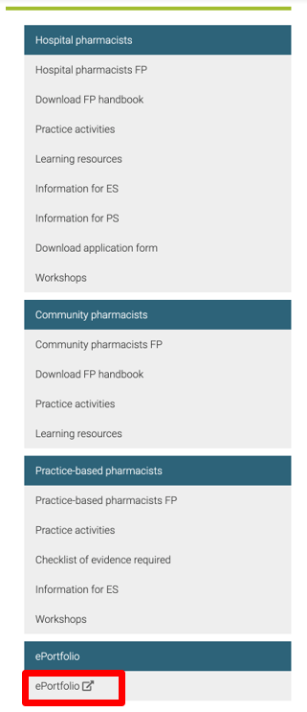

4. Select ‘Portfolio’ to open the portfolio in a new window. You will be automatically logged into the portfolio system as you have already logged into NICPLD.

Remember you must log into the NICPLD website (see Step 1) before you can access the Portfolio system.

How to navigate between the Domains and Competencies

1. When you initially enter the portfolio system, you will see a set of four Domains, presented as coloured boxes. The four Domains are Patient and pharmaceutical care, Professional practice, Personal practice and Management and organisation. Simply click on a Domain to access it.

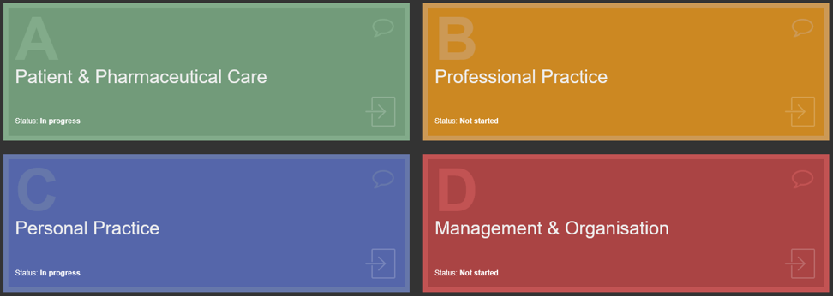

2. Within each Domain, you will be presented with a set of Competencies relevant to that Domain.

For example, the Domain Patient and pharmaceutical care, contains 9 Competencies labelled 1.1, 1.2, 1.3… etc. (four of which are shown in the screen shot below).

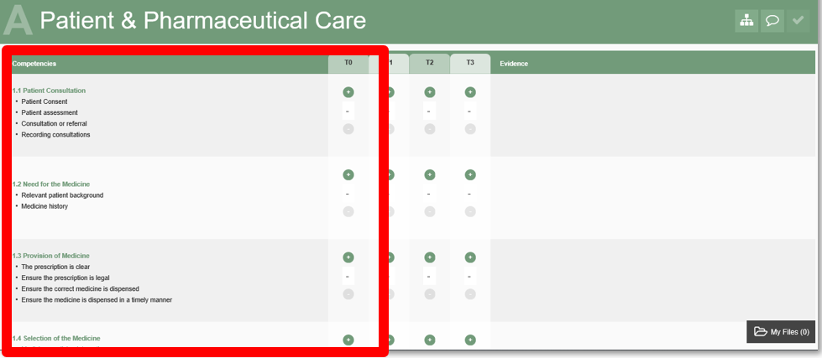

How to add a rating to a competency

1. A self-assessment ratings panel is located to the right-hand side of the Competencies. This panel allows you to self-assess your competence level at four time-points during the course. These time-points (T) are designated as T0 (start of course), T1, T2 and T3 (end of course).

The + button allows you to increase your self-assessment rating and the – button allows you to decrease your self-assessment rating.

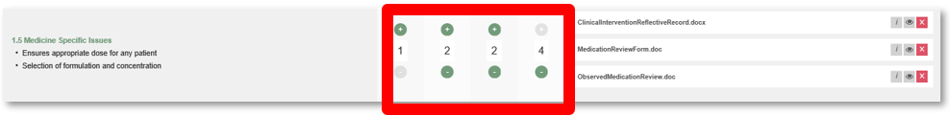

2. Before beginning to collect evidence, you should familiarise yourself with the four Domains and associated Competencies. You must assign a self-assessment rating to each competency at T0 before you attach uploaded evidence to a competency.

How to upload a piece of evidence into the portfolio

1. To upload evidence to the portfolio, open the file manager. To do this, select the button entitled “My files” which is located at the bottom right-hand corner.

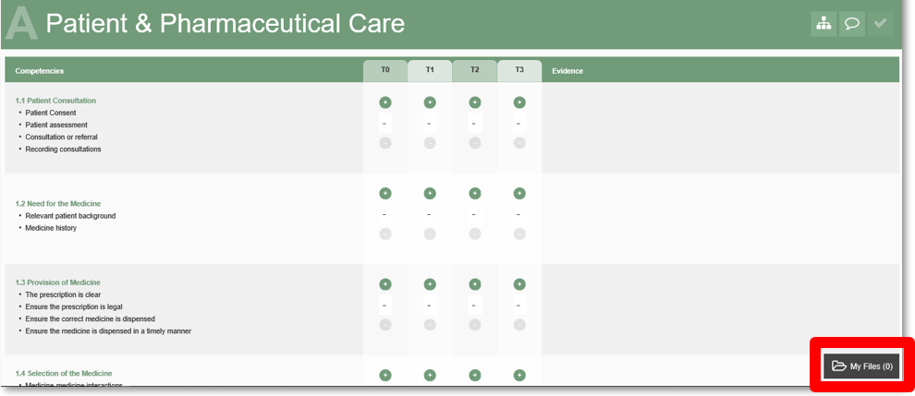

2. If this is your first time opening the file manager, the list will be empty as you have not uploaded any files yet. Click ‘Upload file’ to begin uploading a new file to your portfolio.

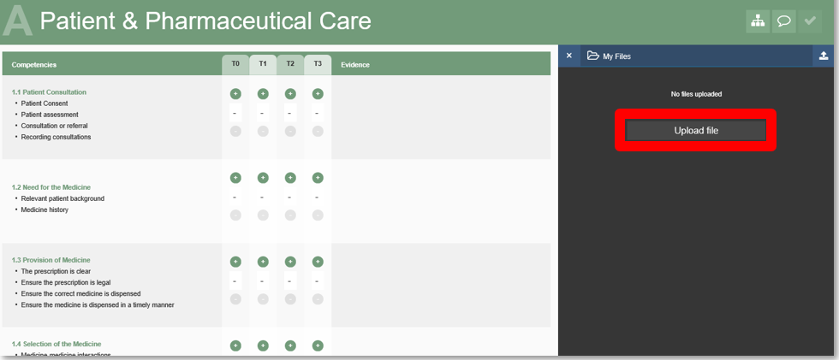

3. After clicking ‘Upload file’ the screen below will appear. To upload a new file, click on the “Choose file” button.

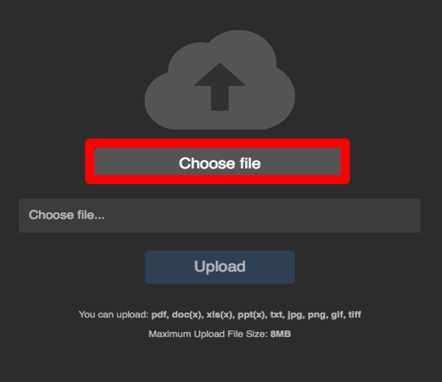

4. The browser file finder window will now open. Use this to navigate to the file on your computer that you wish to upload and click “Open”.

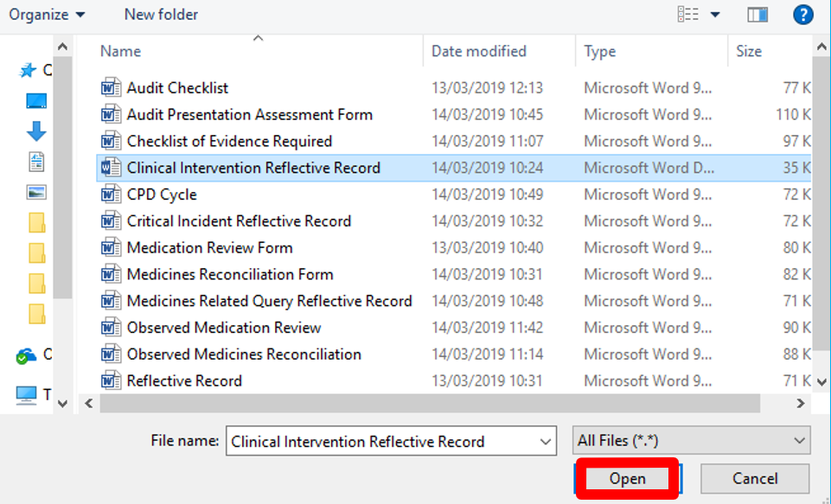

5. The file will now be selected and ready for upload. Click the ‘Upload’ button as highlighted below to complete the upload of the file into the Portfolio.

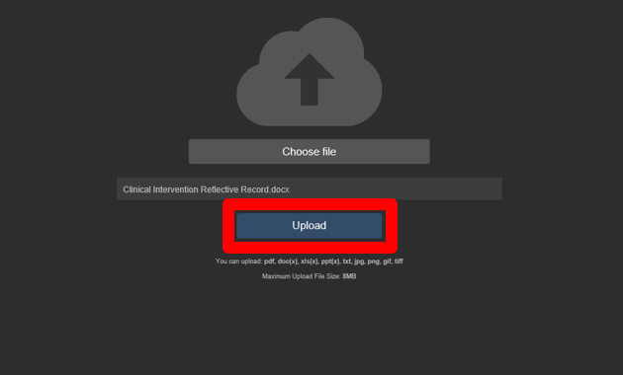

6. The newly uploaded file will now be visible in the file manager window in the Portfolio appearing at the top of the list. The list is ordered by upload in date descending order, i.e. newest first.

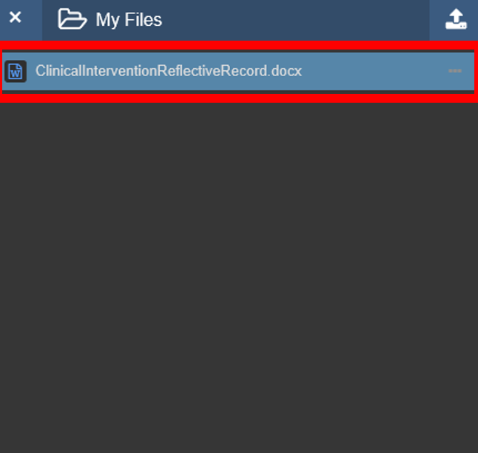

How to attach an uploaded piece of evidence to a competency

1. Before you can attach an uploaded piece of evidence to a competency, you must apply a rating to that competency at T0.

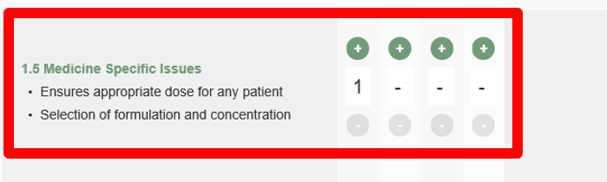

2. Having applied a rating to each competency at T0, an uploaded piece of evidence is then available to provide evidence against one or more Competencies.

In order to link an uploaded file to a particular Competency, drag the file to the ‘Evidence’ column (right-hand side of the self-assessment ratings panel) of that Competency.

You may use one piece of evidence (uploaded file) against a maximum of two competence statements by repeating this process in the relevant competence statements. For example, if the file labelled ‘ClinicalInterventionReflectiveRecord.docx’ provides evidence against 3.1 and 3.2 then drag ‘ClinicalInterventionReflectiveRecord.docx’ from the right hand side to 3.1 and repeat this procedure dragging ‘ClinicalInterventionReflectiveRecord.docx’ again from the right hand side to 3.2.

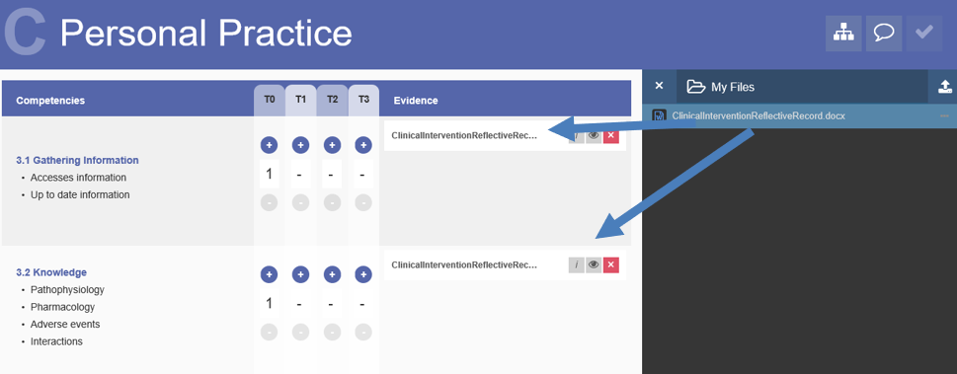

How to communicate with your Educational Supervisor

1. To communicate with your Educational Supervisor on matters relating to the portfolio, click on the speech bubble button to open the communications window. This has been highlighted on the image below.

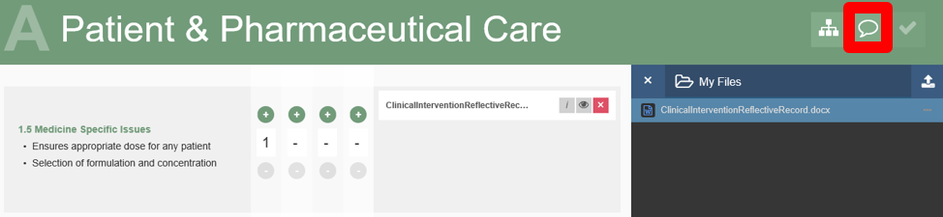

2. The communications window will open and you can add a comment by completing the “Add comment” field at the top and selecting “Submit”. This will add your comment to the top of the list of messages below. The messages are ordered in date descending order.

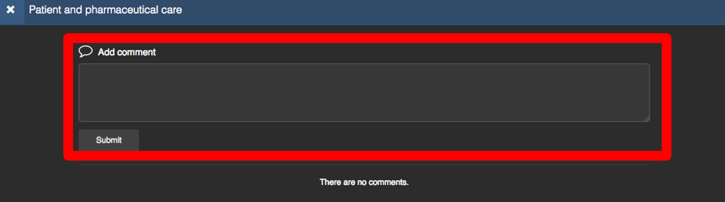

Comments are not emailed to your Educational Supervisor, instead they can be viewed by your Educational Supervisor when they view your portfolio.

Each Domain has its own separate communication channel. Therefore, you will not see messages from Domain A in Domain B or any other Domains.

How to complete your Domains for review

1. In order to complete your Domain, click on the ‘Complete Domain’ icon, highlighted on the image below.

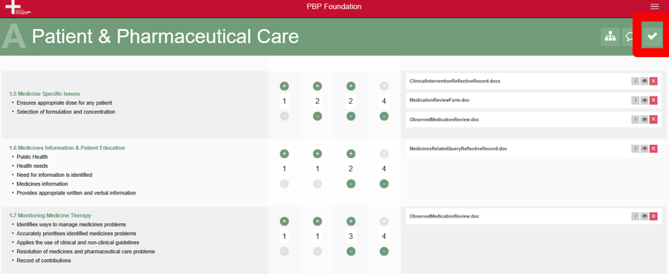

Please note, the following criteria must be met to enable you to complete the Domain.

- You must score yourself in all four time-points for each competency within the Domain.

- The T3 time-point in all competencies within the Domain must have a score rating of 4.

- All competencies within the Domain must include at least one piece of linked evidence.

By default, the ‘Complete Icon’ is disabled. This will become enabled once the above criteria are met. The images below display the disabled and enabled states of the ‘Complete Domain’ icon.

Complete Domain Icon Disabled

Complete Domain Icon Enabled

Domain CANNOT be completed

Domain CAN be completed

2. To complete your Domain, click on the Complete Domain Icon.

3. A modal window will open, to confirm you are happy with marking the Domain as ‘completed’. To finalise the completion, click ‘Completed’.

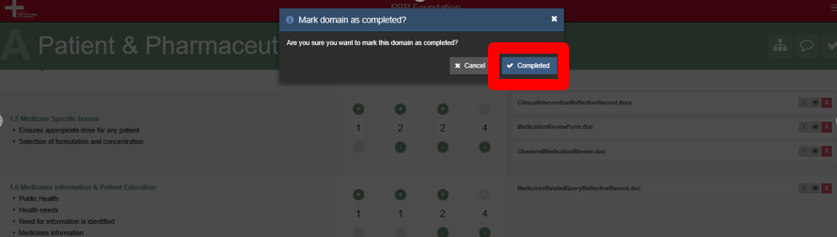

4. Once you complete the Domain, you will be returned to your Domains page. Please note the blue tick graphic and the updated status of ‘Completed – under Supervisor review’ on the Completed Domain.

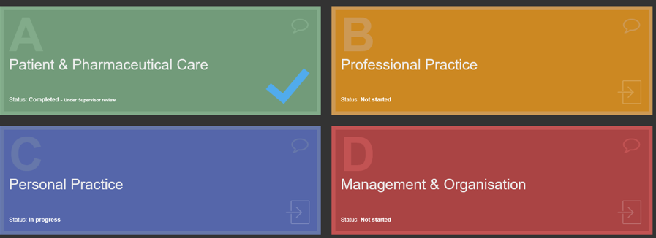

5. Upon selecting a Completed Domain, you will also notice the ‘Complete Domain’ icon has been updated, indicating the new completed status.

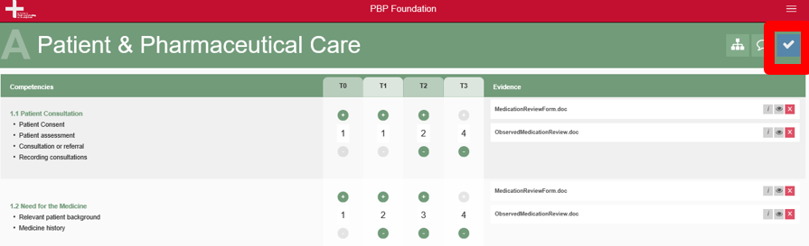

Please note. Once you mark your Domain as completed, you can still adjust:

- all your scoring ratings for all time intervals, within all competencies

- all your submitted evidence against each competency (you can add further supporting evidence if required).

Upon adjusting, you may be prompted (if you have not met the completion criteria) that your Domain will be marked as ‘Incomplete’, and will require you to re-complete it again, see image below.

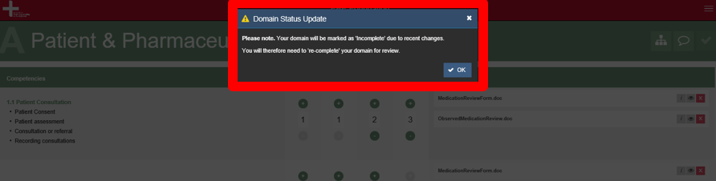

How to submit your completed portfolio to NICPLD for assessment

1. Once you have marked all Domains as complete, you will be returned to your Domains page.

Please note the blue tick graphics and the updated status of ‘Completed – under Supervisor review’ on all Completed Domains.

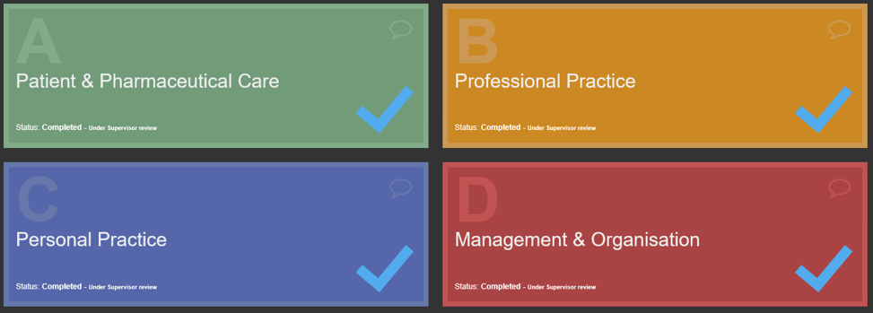

At this point, or at the deadline for the practice portfolio submission date (whichever occurs first), the portfolio will be deemed as final and no longer available for you to access.

Your portfolio will then be assessed by NICPLD. You will be contacted by NICPLD if any remedial work is required.

