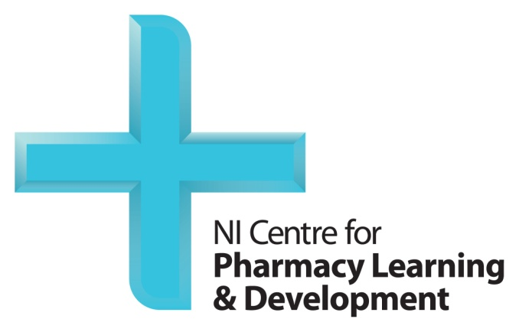

Post-reg Foundation Programme (FP2)
Proficient Patient Care (PPC) – reading list.

CbDs A: Respiratory disease pre-reading:
Asthma e-learning course: https://www.nicpld.org/online/asthma/#m0-introduction
COPD e-learning course: https://www.nicpld.org/online/copd/#m0-introduction
CbDs B: Diabetes pre-reading:
Managing Type 1 diabetes e-learning course: https://www.nicpld.org/online/diabetes-type1/#m0-introduction
Managing Type 2 diabetes e-learning course: https://www.nicpld.org/online/diabetes-type2/#m0-introduction
Long-term complications e-learning course: https://www.nicpld.org/online/diabetes-complications/#m0-introduction
CbDs C: Cardiovascular disease pre-reading:
Cardiovascular risk e-learning course: https://www.nicpld.org/online/cv_risk/#m0-introduction
Heart failure e-learning course: https://www.nicpld.org/online/heart_failure/#m0-introduction
CbDs D: Antimicrobials pre-reading:
Common infections e-learning course: https://www.nicpld.org/online/antimicrobial_common_infections_18/#m0-introduction
Stewardship e-learning course: https://www.nicpld.org/online/antimicrobial_stewardship/#m0-introduction
CbDs E: Cancer pre-reading:
Supportive Medicines in Cancer recorded webinar Part 1: https://vimeo.com/manage/videos/678164769/ccc5afdd04
Supportive Medicines in Cancer recorded webinar Part 2: https://vimeo.com/manage/videos/680840594/936f618167

